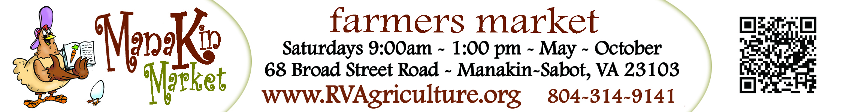
MARKETEER CLUB - RULES FOR PARTICIPATION
- Only children 6-16 and are eligible to participate.
- Each participating child must sign-up online, just like a regular vendor. To apply, go to: http://www.managemymarket.com/landing.aspx?orgID=260
- All items must be homegrown or homemade by the participating child.
- If offering prepared foods (such as brownies or cookies), they must be individually pre-wrapped due to health regulations.
- Eggs must be kept in a cooler. The eggs must be kept at 41° and a thermometer needs to be in the cooler at all times.
- All items must be labeled with a price.
- Each child must bring a table no more than 6’ long for displaying their wares.
- Each child must be responsible for collecting their own money. (A purse or box is useful for storing money).
- There is a $15 Application Fee for the entire season. No other fees apply.
- Marketeers Club vendors can come on the last Saturday of each month, but must still apply and be pre-approved and pay the $15 fee.
- It is preferable that Marketeers Club vendors bring a tent.
- All children must arrive and be ready to vend when the market opens at 9:00am and are expected to stay until closing at 1:00pm.
All products sold at the market must be homegrown, homemade, or handcrafted by the vendor. Such items include, but are not limited to: fruits, vegetables, plants, herbs, flowers, baked goods, honey, jams and jellies, eggs, cheeses, sandwiches, soap, pottery, wooden bowls, paintings, and photography. Items necessary for vendor displays, such as non-handmade vases for cut flowers, will be permitted. All children will be accepted on a first come, first served basis due to space limitations. Market Manager reserves the right to refuse certain products for sale.

